Directions to Harvest Christian Center:
1345 New Harvest Place
El Paso, TX 79912
1-25 South to Las Cruces
Highway 10 South to El Paso (1-25 south turns into Highway 10 just past Las Cruces)
Exit on right to S. Desert Blvd (Rudy’s BBQ on the right)
Turn Left onto Paseo Del Norte
Go over interstate and turn right on Northwestern Dr.
Turn right into church parking lot
If you miss turn go to Helen of Troy and turn right
Then turn right on New Harvest Place

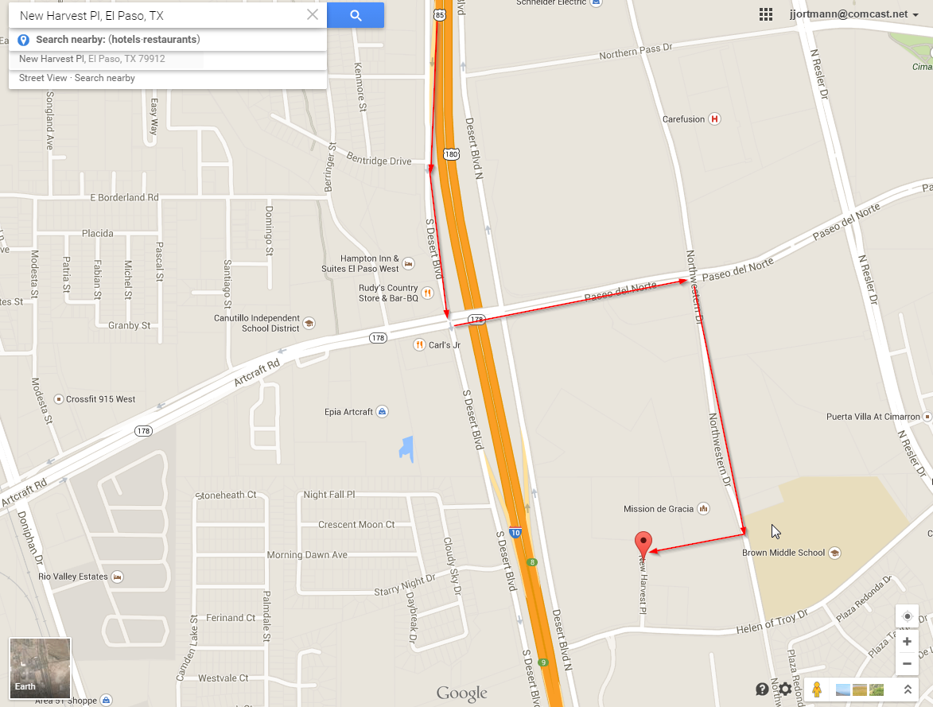
See Map Below:

