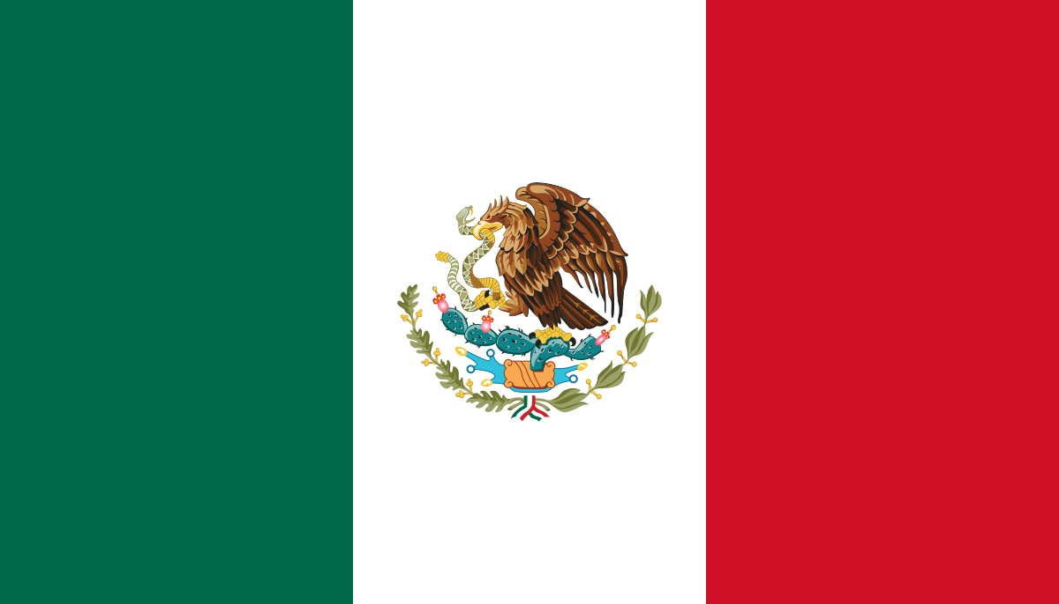

Highpoint International Mission Trips

guadalajara Information Packet

2019

**Emergency Contact Information**

**Staff and In-Country Contacts:**

**Pre-Trip(s) Contact:**

**Brooke Lusher, Operations Director**

**Cell:** 757-202-6186 **Email:** blusher@chcc.org

**Main Person of Contact**

**Josh Mackey, Team Leader**

**Cell:** 616-319-3675 **Email:** jmackey@chcc.org

**Daily Updates While on Mission:**

**Facebook: “Highpoint Guadalajara Mission Trips 2019”**

**U.S. Contact, “At Home” Representtive:**

**Cherry Hills Community Church**

Ruby Fast and Kevin Ross

**Phone:** 303-791-4100

**Email:** Rfast@CHCC.org; KRoss@CHCC.org

**US Embassy in Mexico**

Paseo de la Reforma 305

Cuauhtemoc, 06500 Ciudad de Mexico

Ambassador: William H. Duncan

**Telephone**: +52 55 5080 2000

www.mx.usembassy.gov

**Mexican Embassy in the us**

1911 Pennsylvania Ave NW, Washington, DC 20006     
Telephone: (202) 728-1600

[**WWW.embamex.sre.gob.mx/eua/index.php/es/**](http://WWW.embamex.sre.gob.mx/eua/index.php/es/)

**To Call Mexico from the US:** 011 (52) + (local number)

**To Call US from Mexico:** +001+ (number)

**Guadalajara and Mexico Facts**

* Currency: 1 US Dollar = 18 Mexican Pesos
* Guadalajara is in the same time zone as Central Time (1 hour ahead of Denver)
* Guadalajara is the 2nd largest city in Mexico
* 82.7% of Mexico identifies their religion as Roman Catholicism
* Guadalajara is ranked the 8th best city to visit in Mexico and South America
* The average temperature in Guadalajara in March is 85 degrees
* Mexico is the most populous Spanish speaking country in the world
* Mexico is the world’s largest producer of silver

**Flights**

**All flights are with American Airlines**

**Saturday, March 16**

**\* Arrive to dia at 5:00 am at AA entrance**

* Denver to Phoenix/ 8:01 am to 9:03 am, Flight AA 1404
* Phoenix to Guadalajara/ 1:25 pm to 5:00 pm, Flight AA 5902

**Saturday, March 23**

* Guadalajara to Dallas/ 1:08 pm to 4:47 pm, Flight AA 387
* Dallas to Denver/ 6:45 pm to 7:42 pm, Flight AA 2235

**TRAVEL INFORMATION:**

* **Flights subject to slightly change. Any changes you will be notified.**
* Guadalajara is in the same time zone as Central Time (1 hr ahead of Denver)
* Please arrive at DIA 3 hours prior to departure at 5:00 am! Staff and Leaders will meet you at the American Airlines entrance
* Please bring money for food on our airport travel days. We do have some layovers that allow for us to eat a full meal!

**Helpful Travel Information**

**Passports**

* Always carry your passport with you. Memorize your passport number in case it’s lost or stolen. Leave a passport copy with your parents at home. At the time of final payment we will have you turn in a color photo copy of your passport. Additionally, upon arrival in Nicaragua staff will collect all passports and store in a safe place.

**Airport Expectations**

* Never walk around the airport alone. Always stay with your assigned leader.

**General Health and Food Safety**

* Before you leave, call or make an appointment with your local travel medicine clinic to ensure your vaccinations are up to date, and you have all the suggested medications.
* The best ways to avoid becoming ill are washing your hands with soap and water or antibacterial gel regularly, drinking plenty of non-caffeinated beverages, and getting plenty of rest. We will only serve you clean and well prepared food!
* If you would like to research option vaccines and immunizations, we recommend <http://www.travelcareworldwide.com>. You can reach them by phone at 303-706-0027. They offer discount costs for people traveling on mission trips.

**Clothing**

* Dressconservatively. Shorts are acceptable for extremely hot weather, but shorts should be modest! Capped sleeved t shirts only, no tank tops. One piece bathing suit is required for girls.
* Wear minimal make up, and little or no jewelry. Avoid flashy or expensive clothing and accessories. We will be getting dirty!
* Pack light, do not travel with valuables, and carry important documents or items with you.
* Youwill spend a good deal of time walking. Be certain to bring comfortable, closed toed walking shoes.
* Be prepared for inclement weather. We will be there during the rainy season so there will be intermittent showers

**Insects**

* DEET is the most effective insect repellent against most biting insects.
* Avoid scented soaps, cologne, perfume, lotions, etc that can attract insects.

**Health and Travel Insurance**

CHCC will purchase traveler’s insurance, including emergency evacuation insurance, for each team member. However, if you would like to purchase plans that cover a full trip cancellation, please email Brooke at blusher@chcc.org

**Medicines**

* If you plan to bring prescription drugs, be sure they have a pharmacy label and pack them in your carry-on luggage.
* Leaders will always carry a small personal first aid kit including Imodium, a z-pack, antibiotic ointment, Band-Aids, aspirin, and antihistamines or decongestants.

**Internet/Cell Phone/PDA Access**

Students can use their cell phones on travel days, but once in Mexico we will prohibit them from being used. Staff will have their cell phones on them at all times in case a parent needs to get in contact with a student. Additionally, if parents are worried about having constant contact with their child, Highpoint staff will update our group Facebook page daily. The group Facebook page where you can access these updates is Highpoint Guadalajara Mission Trips 2019.

**Daily Itinerary**

**Will be handed out at first mandatory meeting on December 13.**

**Packing List**

* - 10 Changes of work clothes: Knee length shorts/pants and short sleeve t-shirts.
  1. -  1 set of Church clothes. Girls- skirt/dress/capris to the knees. Guys- long pants and collared shirt
* - Long shorts/ T-Shirts for free time and bed time
* -  Undergarments
* -  Sneakers (closed toe shoes)
* -  Sandals with backs
* -  Flip-flops for shower
* -  Swim suit (Modest one piece only girls)
* -  Towel
* -  Rain jacket
* -  Bandana or Hat
* -  Sweatshirt
* -  Flash light/Headlamp
* -  Camera
* -  Bible/Journal/pen
* -  Daily toiletries
* -  Sunscreen
* -  Medicine (prescribe or over the counter)
* -  Bug Spray
* -  Extra money- crisp, large face bills (airport food, gifts/souvenirs from market)
* -  Passport and a copy of your passport
* -  Empty Water bottle
* -  Light Blanket if desired
* -  Protein bars/nuts/beef jerky/fruit leathers
* -  Playing cards for free time
* * **NOTE It could rain or we could have a dirty work day so please pack enough clothes in the event that you may change more than once a day. Please stay away from flashy American logos and advertisements. Also, neither guys nor girls should bring ANY clothing that is too tight, small, revealing, or form fitting.**
* **Daily Backpack**
* Bottle of drinking water
* Personal snacks
* Pen and notepad
* Bible
* Sunscreen & Lip Balm
* Antibacterial hand sanitizer
* Insect repellant
* Tissue
* Hat, light rain jacket & other appropriate clothing or equipment for inclement weather.

**Things NOT To Pack**

* -  Ipods
* -  Computers/Ipads
* -  Drugs/Alcohol/Illegal substances
* -  Hairdryers, curling irons, straighteners

**Safety**

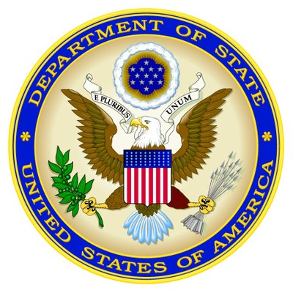**From the U.S. Department of State**

For the latest security information, Americans traveling abroad should regularly monitor the Department of State, Bureau of Consular Affairs’ website at <http://travel.state.gov>, where the current travel warnings and travel alerts, as well as the worldwide caution, can be found.

Up to date information on safety and security can also be obtained by calling 1-888-407-4747 toll free in the U.S. and Canada, or for callers outside the U.S. and Canada, a regular toll-line at 1-202-501-4444.

The Department of State urges American citizens to take responsibility for their own security while traveling overseas. For general information about appropriate measures travelers can take to protect themselves in an overseas environment, see the Department of State’s pamphlet “A Safe Trip Abroad,” on the website.

The loss of theft abroad of a U.S. passport should be reported immediately to the local police and the nearest U.S. Embassy or Consulate. If you are the victim of a crime while overseas, in addition to reporting to local police, please contact the nearest U.S. Embassy or Consulate for assistance. The Embassy/Consulate staff can, for example, assist you to find appropriate medical care, contact family members or friends and explain how funds could be transferred.

U.S. citizens should carry a copy of their U.S. passport with them at all times. Credit cards may be used at some major hotels, but are not widely accepted in Nicaragaua.  In the larger urban areas, ATM machines are usually available at major banks.  However, travelers should exercise caution when using ATM, debit, and credit cards in Nicaragua.  There have been numerous recent reports from U.S. citizens of fraud, particularly against U.S. dollar denominated accounts.

Travelers should bring sufficient cash or traveler’s checks for their trip if they will be spending time outside of the large cities.  Individuals should be advised that reputable financial institutions require that the holder of Travelers Checks present the original receipt for the checks and proof of identity before the institutions will complete a transaction.

**Mission Trip Meeting Dates**

-**December 13 in Pavilion 2** from 6:00-7:00 pm. Students & Parents/Guardians Required

-**January 17 in Pavilion 1** from 6:00-7:00 pm. Students only. Required.

-**February 21 in Pavilion 2** from 6:00-7:00 pm. Students only. Required.

**NOTE:** ALL Meetings will take place in the Pavilions, the new section of building off of the Cherry Hills main lobby/main entrance off of Fairview Pkwy. These are required meetings in order to attend the trip.

**PAYMENT DEADLINES**

-**TO SECURE SPOT** - $100

**-DECEMBER 13 -** $550.00

-**JANUARY 17 -** $1,000.00

**-FEBRUARY 21-** $1,550.00 | FULLY PAID