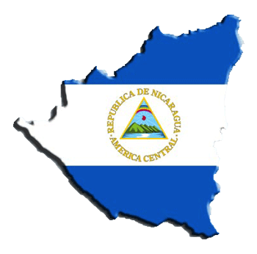

Highpoint International Mission Trip

Nicaragua Information Packet

2018

**Table of Contents**

Found within this packet is a host of information provided by Highpoint that is intended to assist in your trip to Nicaragua. Below is an outline of what is found within this Information Packet:

Emergency Contact Information 2

Nicaragua Facts 3

Flight Itinerary 4

Helpful Travel Information 5

Daily Schedule 7

Packing List 8

Safety Information from the Department of State 11

Mission Trip Meeting Dates & Payment Deadlines 12

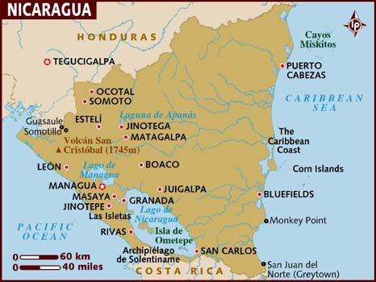

**Emergency Contact Information**

**Staff and In-Country Contacts:**

**Main Person of Contact:**

**Brooke Lusher, Team Leader**

**Cell:** 757-202-6186 **Email:** blusher@chcc.org

**Secondary Person of Contact:**

**Bryan Ratanasin, Team Leader**

**Cell:** 720-284-4204 **Email:** bratanasin@chcc.org

**Daily Updates While on Mission:**

**Facebook: “Highpoint Nicaragua Mission Trip 2018”**

**U.S. Contact, “At Home” Representtive:**

**Cherry Hills Community Church**

Ruby Fast or Kevin Ross

**Phone:** 303-791-4100

**Email:** [Rfast@CHCC.org](mailto:Rfast@CHCC.org) or Kross@chcc.org

**US Embassy in Nicaragua**

Kilometer 5.5 Carretera Sur,

Managua, Nicaragua

Ambassador: Charles C. Barclay

**Telephone**: (505) 2252-7100

www.nicaragua.usembassy.gov

acs.managua@state.gov

**Nicaraguan Embassy in the us**

1627 New Hampshire Ave, NW, Washington D.C 20009     
Telephone: (202)939-6570

**www.Nicaraguaembassy-us.org**

Ambassador: **Robert L. Callahan**

**To Call Nicaragua from the US:** 011 (505) + (local number)

**To Call US from Nicaragua:** +001+ (number)

**Nicaragua Facts**

* Nicaragua is the largest country in Central America, about the size of New York State!
* It is home to the largest lake in Central America and more than 20 volcanic peaks. Nicaragua is often referred to as “the land of lakes and volcanoes”.
* Nicaragua is neighbored by Honduras and Costa Rica, bordered on the east by the Caribbean Sea and on the west by the Pacific Ocean.
* There are only 5.7 million people who live in Nicaragua. Even though it is the largest country in Central America, it has the least number of people living there.
* Language: Spanish
* Capitol City: Managua
* Money: The Nicaraguan Córdoba (C$) is the local currency. 1 US Dollar is the equivalent to C$31.15
* Nicaragua is the second poorest country in the Western Hemisphere.
* 45% of the population lives on less than 1 US Dollar a day.
* 60% unemployment rate.
* The climate is tropical and the average temperature is 80 degrees.
* Baseball is the most popular sport and younger kids love to play tag and soccer.
* A traditional Nicaraguan meal consists of eggs or meat, beans and rice (Gallo Pinto), tortillas and fruit.
* 1 of every 3 Nicaraguan children has some degree of malnutrition and 1 in 4 children are born to a teenage mother.

**Flight Itinerary**

**All flights are with American Airlines**

**June 2nd 2017**

* **Denver to Miami, 10:21 am to 4:29 pm**
* **Miami to Managua, 5:52 pm to 6:37 pm**

**June 9th 2017**

* **Managua to Dallas, 3:56 pm to 8:50 pm**
* **Dallas to Denver, 10:25 pm to 11:29 pm**
* Flights are subject to slightly change. Any changes you will be notified.
* Managua, Nicaragua is in the same time zone as Colorado
* Please arrive at DIA 3 hours prior to departure, 7:20 am on June 2nd. Staff and Leaders will meet you at the American Airlines entrance
* Please bring money for food on our airport travel days. We may have time during layovers to eat a meal!

**Helpful Travel Information**

**Passports**

* Always carry your passport with you. Memorize your passport number in case it’s lost or stolen. Leave a passport copy with your parents at home. At the time of final payment we will have you turn in a color photo copy of your passport. Additionally, upon arrival in Nicaragua staff will collect all passports and store in a safe place.

**Airport Expectations**

* Arrive at least 3 hours prior to your international departure time.
* Never walk around the airport alone. Always stay with your assigned leader.

**General Health and Food Safety**

* Before you leave, call or make an appointment with your local travel medicine clinic to ensure your vaccinations are up to date, and you have all the suggested medications. If you have any questions, Project El Crucero can help you locate a travel medicine clinic in your area.
* The best ways to avoid becoming ill are washing your hands with soap and water or antibacterial gel regularly, drinking plenty of non-caffeinated beverages, and getting plenty of rest. We will only serve you clean and well prepared food!
* If you would like to research option vaccines and immunizations, we recommend <http://www.travelcareworldwide.com>. You can reach them by phone at 303-706-0027. They offer discount costs for people traveling on mission trips.

**Insects**

* DEET is the most effective insect repellent against most biting insects.
* Avoid scented soaps, cologne, perfume, lotions, etc. that can attract insects.

**Health and Travel Insurance**

CHCC will purchase traveler’s insurance, including emergency evacuation insurance, for each team member.

**Medicines**

* If you plan to bring prescription drugs, be sure they have a pharmacy label and pack them in your carry-on luggage.
* Be sure to bring any medicine you think you might need: For example- Imodium, a z-pack, antibiotic ointment, Band-Aids, aspirin, and antihistamines or decongestants

**Internet/Cell Phone Access**

Students can use their cell phones on travel days, but once in Nicaragua we will collect them from students. Staff will have their cell phones on them at all times in case a parent needs to get in contact with a student. Additionally, if parents are worried about having constant contact with their child, Highpoint staff will update our group Facebook page daily. The group Facebook page where you can access these updates is Highpoint Nicaragua Mission Trip 2018.

**Daily Schedule**

**June 2**

Travel- Depart at 10:30 am and arrive in Managua at 4:30 pm. Bonfire with the team.

**June 3**

Breakfast, Church, Lunch, Sports Program, Water games with local kids, Dinner, Young Life with local youth, Debrief, Team worship

**June 4**

Breakfast, Scavenger hunt at Market, Lunch, Prayer Walking & Working on farm, Dinner, Young Life with local youth, Debrief, Worship

**June 5**

Fun Day – Swimming in Volcanic Crater Lake, Dinner, Worship, Bonfire

**June 6**

Breakfast, Dump Ministry & Prayer Walking, Lunch, Children’s VBS, Dinner, Young Life with local youth, Debrief, Worship

**June 7**

Breakfast, Prayer Walking & Working on farm, Lunch, Prayer Walking & Working on Farm, Dinner, Alpha Course, Debrief, Worship

**June 8**

Fun Day – Shopping, Ziplining, Dinner, Final Debrief, Worship, Bonfire

**June 9**

Travel- Depart at 3:56 pm and arrive in Denver at 11:29 pm

**Packing List**

* - ***MUST*** limit belongings to ONE checked bag weighing under 50 lbs.
* -  Enough play and work clothes for each day
* -  1 set of Church clothes. Skirt/dress/capris to the knees (Girls), Long pants and collared shirt (Guys)
* - Knee-length athletic shorts to play and work in
* - Jeans, khakis, or slacks with no holes and/or loose fitting capri pants (No leggings or yoga pants)
  + 1. - Enough t-shirts to play and work in (No tank tops, Scoop necks or Deep V shirts)
* -  Undergarments
* -  Sneakers/closed toe shoes (We will be doing a lot of walking)
* -  Sandals with backs (ex. Chacos, Tivas)
* -  Flip-flops for shower
* -  Swim suit (One pieces ONLY for girls, No speedos for guys)
* -  Towel
* -  Rain jacket (We will be there during the rainy season)
* -  Bandana or Hat
* -  Sweatshirt
* -  Flash light/Headlamp
* -  Camera
* -  Bible/Journal/pen
* -  Daily toiletries
* -  Sunscreen
* -  Medicine (prescribe or over the counter)
* -  Bug Spray
* -  Extra money- crisp, large face bills (airport food, gifts/souvenirs from the market to bring home)
* -  Passport (and a colored copy of your passport to turn into staff)
* -  Empty Water bottle
* -  Light Blanket if desired
* -  Protein bars/nuts/beef jerky/fruit leathers
* -  Playing cards for free time
* *\* Reminder: It could rain or we could have a dirty work day so please pack enough clothes in the event that you may change more than once a day.*
* **Daily Backpack**
* Bottle of drinking water
* Personal snacks
* Pen and notepad
* Bible
* Sunscreen & Lip Balm
* Antibacterial hand sanitizer
* Insect repellant
* Tissue
* Hat, light rain jacket & other appropriate clothing or equipment for inclement weather.

**Things NOT To Pack**

* -  Ipods
* -  Computers/Ipads
  + - 1. - Minimal make-up and little to no jewelry – Avoid flashy or expensive clothing and

accessories. (We will be getting dirty!)

* + 1. - Clothes with flashy American logos or advertisements
* -  Drugs/Alcohol/Illegal substances
* -  Hairdryers, curling irons, straighteners

**Safety**

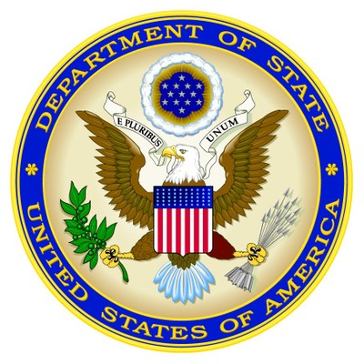**From the U.S. Department of State**

For the latest security information, Americans traveling abroad should regularly monitor the Department of State, Bureau of Consular Affairs’ website at <http://travel.state.gov>, where the current travel warnings and travel alerts, as well as the worldwide caution, can be found.

Up to date information on safety and security can also be obtained by calling 1-888-407-4747 toll free in the U.S. and Canada, or for callers outside the U.S. and Canada, a regular toll-line at 1-202-501-4444.

The Department of State urges American citizens to take responsibility for their own security while traveling overseas. For general information about appropriate measures travelers can take to protect themselves in an overseas environment, see the Department of State’s pamphlet “A Safe Trip Abroad,” on the website.

The loss of theft abroad of a U.S. passport should be reported immediately to the local police and the nearest U.S. Embassy or Consulate. If you are the victim of a crime while overseas, in addition to reporting to local police, please contact the nearest U.S. Embassy or Consulate for assistance. The Embassy/Consulate staff can, for example, assist you to find appropriate medical care, contact family members or friends and explain how funds could be transferred.

U.S. citizens should carry a copy of their U.S. passport with them at all times. Credit cards may be used at some major hotels, but are not widely accepted in Nicaragaua.  In the larger urban areas, ATM machines are usually available at major banks.  However, travelers should exercise caution when using ATM, debit, and credit cards in Nicaragua.  There have been numerous recent reports from U.S. citizens of fraud, particularly against U.S. dollar denominated accounts.

Travelers should bring sufficient cash or traveler’s checks for their trip if they will be spending time outside of the large cities.  Individuals should be advised that reputable financial institutions require that the holder of Travelers Checks present the original receipt for the checks and proof of identity before the institutions will complete a transaction.

**Mission Trip Meeting Dates**

-**March 18**from 4 to 5 pm. Students & Parents Invited

-**April 8** from 4 to 5 pm. Students only. Trip preparation.

-**May 13** from 4 to 5 pm. Students only. Trip preparation.

ALL Meetings will take place in Pavilion 2, the new section of building off of the Cherry Hills main lobby/main entrance off of Fairview Pkwy.

**PAYMENT DEADLINES**

-**TO SECURE SPOT** - $100

-**MARCH 18** - $500.00

-**APRIL 8 -** $1,100.00

**-APRIL 29 -** $1,700.00 | FULLY PAID