CHCC – Service Reef
Uploading a Passport

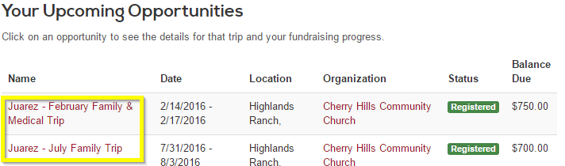
Login into ServiceReef and click on your dashboard. You’ll see your upcoming opportunities. Click on the appropriate opportunity.

Once you have clicked on one of your opportunities, click on the “+” next to “UPDATE PROFILE” and select Passport
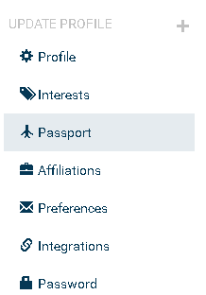

Enter the requested information, click “Choose File” and select “Save Changes”:

