CHCC – Service Reef
Personal/Household Fundraising Page

When you finish applying for an opportunity, you’ll receive an email from ServiceReef thanking you for signing up and providing further details about your personalized trip page. Each applicant or household now has the ability to send out a link to their own fundraising page. Similar to a “Go Fund Me” process.
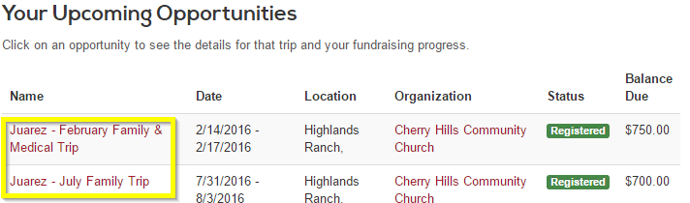
Login into ServiceReef and click on your dashboard. You’ll see your upcoming opportunities. Click on an opportunity.

Once you have clicked on one of your opportunities, you’ll see the below screen. The below link can be shared with family and friends so they can support you. You can also add photos, messages and share stories by clicking the link.
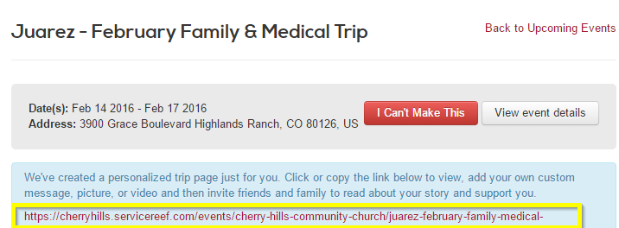

To make edits to this personal page click on the above link and then click the Edit Personalized Content button.
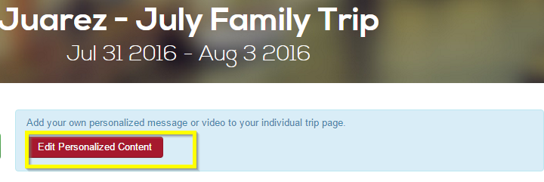

Once you have hit the edit button, the below screen will appear where you can add photos, videos and text. Make sure you click the save changes button at the bottom of the screen when done.
