Spring 2018 Juarez Men’s Trip
Who: 30 men and boys. Boys 8 years old and older are welcome to attend the trip. Feel free to bring your sons. Each person must have a passport.
What: The team will build three homes.
When: April 18-21, 2018
Where: Enter “Missions Ministries Compound” into Google Maps to see where we’ll be staying for the duration of the trip. Missions Ministries has created the following video to give you an idea of the area and the activities that occur on a trip. https://vimeo.com/220395407?ref=fb-share&1
Cost: Per person projected cost is $900.00.
Trip Details: The team will drive in individual vehicles to El Paso on 4/18. Once in El Paso, we will meet our partner mission, Mission Ministries, and travel in their vans across the border to the Missions Ministries Team Center. The Team Center is secured with a wall and guards and consists of 15 private rooms, cafeteria, basketball court and pavilion. The team will be provided three buffet style meals per day with the food prepared to American standards.
The construction part of the trip will take place on 4/19 and 4/20. Construction will begin at 8:30 and end around 4:00 with a break for lunch. If time permits, we will have a prayer walk through one of the local neighborhoods. On the evening of 4/20, we will attend a church service at a local church.
The team will cross back over the border on the morning of 4/21. Team members can expect to be home at around 6:00pm.
Tools to Bring:
- Hammer
- Nail apron
- Safety glasses
- Paint kit (brush, roller pan, 3-4” paint brush, small trim brush, small container for paint)
- Work gloves

Team Meeting: An informational team meeting will be scheduled in the February 2018 timeframe.
Registration Link: https://cherryhills.servicereef.com/events/cherry-hills-community-church/juarez-mens-trip-4
Contact Info: Please feel free to contact me with any questions or if you’d like more info.
John Ortmann
303.476.0360
jjortmann@comcast.net

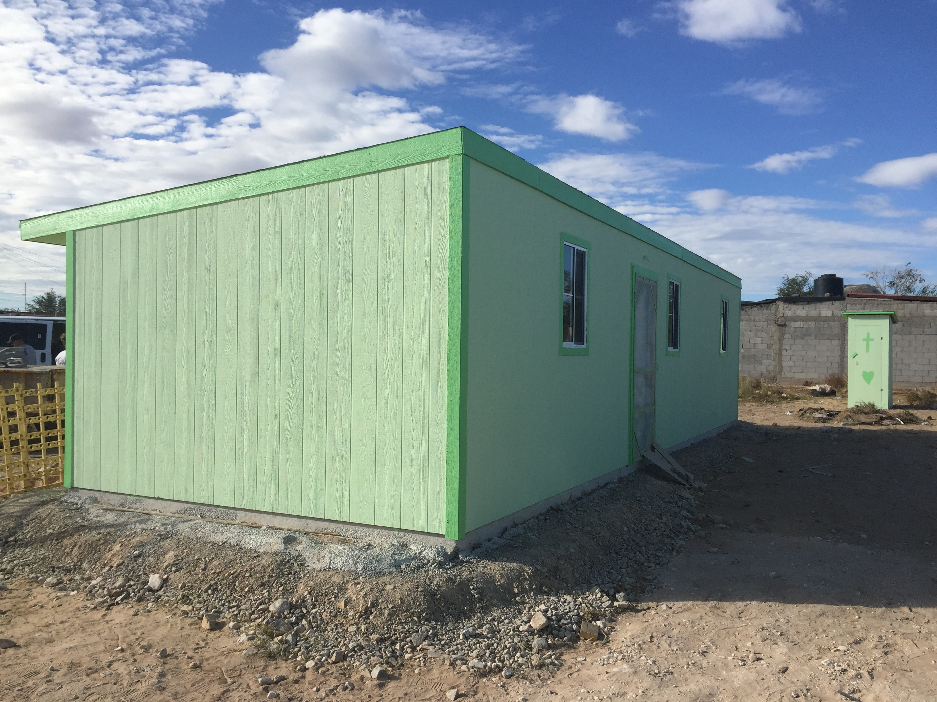
This is the 12x36 standard house building

