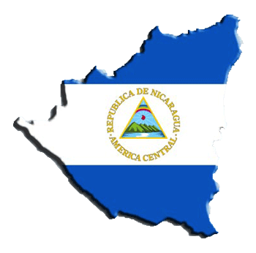

**Highpoint International Mission Trip**

**Nicaragua Information Packet**

**2017**

**Table of Contents**

Found within this packet is a host of information provided by Highpoint that is intended to assist in your trip to Nicaragua. Below is an outline of what is found within this Information Packet:

Emergency Contact Information 2

Nicaragua Facts 3

Flight Itinerary 4

Helpful Travel Information 5

Daily Itinerary 7

Packing List 9

Safety Information from the Department of State 11

Mission Trip Meeting Dates 12

Support Letter Sample 13

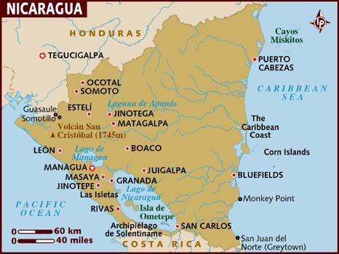

**Emergency Contact Information**

**Staff and In-Country Contacts:**

**Main Person of Contact:**

**Joani Baird, Team Leader**

**Cell:** 360-448-8750 **Email:** jbaird@chcc.org

**Secondary Person of Contact:**

**Bryan Ratanasin, Team Leader**

**Cell:** 720-284-4204 **Email:** bratanasin@chcc.org

**Daily Updates While on Mission:**

**Facebook: “Highpoint Nicaragua Mission Trip 2017”**

**U.S. Contact, “At Home” Representtive:**

**Cherry Hills Community Church**

Abbie Johnson and Kevin Ross

**Phone:** 303-791-4100

**Email:** Abbiejohnson@CHCC.org; KRoss@CHCC.org

**US Embassy in Nicaragua**

Kilometer 5.5 Carretera Sur,

Managua, Nicaragua

Ambassador: Charles C. Barclay

**Telephone**: (505) 2252-7100

www.nicaragua.usembassy.gov

acs.managua@state.gov

**Nicaraguan Embassy in the us**

1627 New Hampshire Ave, NW, Washington D.C 20009     
Telephone: (202)939-6570

**www.Nicaraguaembassy-us.org**

Ambassador: **Robert L. Callahan**

**To Call Nicaragua from the US:** 011 (505) + (local number)

**To Call US from Nicaragua:** +001+ (number)

**Nicaragua Facts**

* Nicaragua is the largest country in Central America, about the size of New York State!
* It is home to the largest lake in Central America and more than 20 volcanic peaks. Nicaragua is often referred to as “the land of lakes and volcanoes”.
* Nicaragua is neighbored by Honduras and Costa Rica, bordered on the east by the Caribbean Sea and on the west by the Pacific Ocean.
* There are only 5.7 million people who live in Nicaragua. Even though it is the largest country in Central America, it has the least number of people living there.
* Language: Spanish
* Capitol City: Managua
* Money: The Nicaraguan Córdoba (C$) is the local currency. 1 US Dollar is the equivalent to C$29.50
* Nicaragua is the second poorest country in the Western Hemisphere.
* 45% of the population lives on less than 1 US Dollar a day.
* 60% unemployment rate.
* The climate is tropical and the average temperature is 80 degrees.
* Baseball is the most popular sport and younger kids love to play tag and soccer.
* A traditional Nicaraguan meal consists of eggs or meat, beans and rice (Gallo Pinto), tortillas and fruit.
* 1 of every 3 Nicaraguan children has some degree of malnutrition and 1 in 4 children are born to a teenage mother.

**Flight Itinerary**

**All flights are with United Airlines**

**June 1st 2017**

* **Denver to Houston, 11:17 am to 2:43 pm. Flight #1819**
* **Houston to Managua, 6:10 pm to 8:25 pm. Flight #1421**

**June 11th 2017**

* **Managua to Houston, 1:00 am to 5:30 am. Flight #1715**
* **Houston to Denver, 9:00 am to 10:31 am. Flight #1126**
* Flights are subject to slightly change. Any changes you will be notified.
* Managua, Nicaragua is in the same time zone as Colorado
* Please arrive at DIA 3 hours prior to departure, 8:17 am on June 1st. Staff and Leaders will meet you at the United Airlines entrance!
* Please bring money for food on our airport travel days. We do have layovers that allow for us to eat a full meal!

**Helpful Travel Information**

**Passports**

* Always carry your passport with you. Memorize your passport number in case it’s lost or stolen. Leave a passport copy with your parents at home. At the time of final payment we will have you turn in a color photo copy of your passport. Additionally, upon arrival in Nicaragua staff will collect all passports and store in a safe place.

**Airport Expectations**

* Arrive at least 3 hours prior to your international departure time.
* Never walk around the airport alone. Always stay with your assigned leader.

**General Health and Food Safety**

* Before you leave, call or make an appointment with your local travel medicine clinic to ensure your vaccinations are up to date, and you have all the suggested medications. If you have any questions, Project El Crucero can help you locate a travel medicine clinic in your area.
* The best ways to avoid becoming ill are washing your hands with soap and water or antibacterial gel regularly, drinking plenty of non-caffeinated beverages, and getting plenty of rest. We will only serve you clean and well prepared food!
* If you would like to research option vaccines and immunizations, we recommend <http://www.travelcareworldwide.com>. You can reach them by phone at 303-706-0027. They offer discount costs for people traveling on mission trips.

**Clothing**

* Dressconservatively. Shorts are acceptable for extremely hot weather, but shorts should be modest! Capped sleeved t shirts only, no tank tops. One piece bathing suit is required for girls.
* Wear minimal make up, and little or no jewelry. Avoid flashy or expensive clothing and accessories. We will be getting dirty!
* Pack light, do not travel with valuables, and carry important documents or items with you.
* Youwill spend a good deal of time walking. Be certain to bring comfortable, closed toed walking shoes.
* Be prepared for inclement weather. We will be there during the rainy season so there will be intermittent showers

**Insects**

* DEET is the most effective insect repellent against most biting insects.
* Avoid scented soaps, cologne, perfume, lotions, etc that can attract insects.

**Daily Backpack**

Bottle of drinking water

Personal snacks

Pen and notepad

Bible

Sunscreen & Lip Balm

Antibacterial hand sanitizer

Insect repellant

Tissue

Hat, light rain jacket & other appropriate clothing or equipment for inclement weather.

**Health and Travel Insurance**

CHCC will purchase traveler’s insurance, including emergency evacuation insurance, for each team member.

**Medicines**

* If you plan to bring prescription drugs, be sure they have a pharmacy label and pack them in your carry-on luggage.
* Leaders will always carry a small personal first aid kit including Imodium, a z-pack, antibiotic ointment, Band-Aids, aspirin, and antihistamines or decongestants.

**Internet/Cell Phone/PDA Access**

Students can use their cell phones on travel days, but once in Nicaragua we will prohibit them from being used. Staff will have their cell phones on them at all times in case a parent needs to get in contact with a student. Additionally, if parents are worried about having constant contact with their child, Highpoint staff will update our group Facebook page daily. The group Facebook page where you can access these updates is Highpoint Nicaragua Mission Trip 2017.

**Daily Itinerary**

**June 1**

Travel- depart at 11:17 am and arrive in Managua at 8:25 pm.

**June 2**

Team training, learning street evangelism dances, team building activities and games, & night commissioning service over Lake Managua.

**June 3**

Street Evangelism with Monte Calvario Church in Managua. Attend Monte Calvario Church Youth Service with local Nicaraguan youth.

**June 4**

Local service project at the orphanage in Managua (building, painting etc). Night service, worship, reflection and team bonding.

**June 5**

Day off to refresh and refuel. A day on the lake with kayaks, tubes and relaxation! We will be going to Monkey Hut outside of Grenada, Nicaragua.

**June 6**

Travel to El Crucero, Nicaragua- a poverty stricken village outside of Managua. Partner with the local clinic to prepare food baskets for the local community. Pass out the food baskets & do street evangelism, inviting the villagers to the VBS program we are hosting the next two days.

**June 7**

Travel to El Crucero to host a VBS program full of English teaching, crafts, soccer/baseball playing and dancing! Love on the kids and the youth and share Christs love.

**June 8**

Travel to El Crucero to host a VBS program full of English teaching, crafts, soccer/baseball playing and dancing! Love on the kids and the youth and share Christs love.

**June 9**

Day off to refuel and celebrate all God has done! Go to a market in Grenada to buy souvenirs/gifts. Go to Monkey Island, a boat tour around the beautiful islands and a place to feed monkeys!

**June 10**

Local service project at the hospital in Managua (building, painting, etc). Attend Monte Calvario Church Youth Service with the Nicaraguan youth and have a pizza party to CELEBRATE all God has done through us with our new brothers and sisters in Christ!

**June 11**

Travel- arrive home at 11:46 am Mockup Itinerary

**Packing List**

* - 10 Changes of work clothes: Knee length shorts/pants and short sleeve t-shirts.
* -  1 set of Church clothes. Girls- skirt/dress/capris to the knees. Guys- long pants and collared shirt
* - Long shorts/ T-Shirts for free time and bed time
* -  Undergarments
* -  Sneakers (closed toe shoes)
* -  Sandals with backs
* -  Flip-flops for shower
* -  Swim suit (Modest one piece only girls)
* -  Towel
* -  Rain jacket
* -  Bandana or Hat
* -  Sweatshirt
* -  Flash light/Headlamp
* -  Camera
* -  Bible/Journal/pen
* -  Daily toiletries
* -  Sunscreen
* -  Medicine (prescribe or over the counter)
* -  Bug Spray
* -  Extra money- crisp, large face bills (airport food, gifts/souvenirs from the market to bring home)
* -  Passport and a copy of your passport
* -  Empty Water bottle
* -  Light Blanket if desired
* -  Protein bars/nuts/beef jerky/fruit leathers
* -  Cards for free time  * Reminder: It could rain or we could have a dirty work day so please pack enough clothes in the event that you may change more than once a day.

**Things NOT To Pack**

* -  Ipods
* -  Computers/Ipads
* -  Drugs/Alcohol/Illegal substances
* -  Hairdryers, curling irons, straighteners
* -  Drugs/Alcohol/Illegal substances
* Remember, it’s only for a week! Thank you in advance for your sacrifice and cooperation!

**Ministry Dress Code**

***In America, we wear what we want and how we want. But it’s different when ministering. We have to consider other people more than ourselves.***

**Girls:**

**-Ministry Dress and or work dress**

**-Short or long sleeve shirts (no cap sleeve or sleeveless/ no scoop neck or deep V neck)**

**-Jeans with no holes**

**-Knee length shorts**

**-Capri loose fitting pants (No yoga pants/No Leggings)**

**-Closed toed shoes/ tennis shoes**

**- Sandals with backs (Ex. Chacos/Tivas)**

**-Skirt/ Dress below the knees with sleeves (Church)**

**Guys:**

* **-  Short or long sleeve shirts with no holes**
* **-  Knee length shorts**
* **-  Jeans with no holes**
* **-  Khaki or slacks**
* **-  Closed toed shoes/ tennis shoes**
* **-  Sandals with backs (Ex. Chacos/Tivas)**

**Please stay away from Flashy American Logos and Advertisements.**

**Also, neither guys nor girls should bring ANY clothing that is too tight, small, revealing, or form fitting.**

**Please respect the people of Nicaragua and our ministry by following this dress code!**

**Safety**

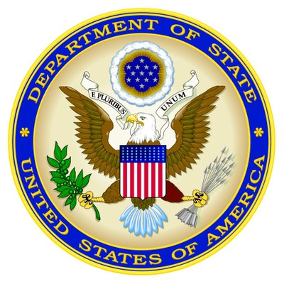**From the U.S. Department of State**

For the latest security information, Americans traveling abroad should regularly monitor the Department of State, Bureau of Consular Affairs’ website at <http://travel.state.gov>, where the current travel warnings and travel alerts, as well as the worldwide caution, can be found.

Up to date information on safety and security can also be obtained by calling 1-888-407-4747 toll free in the U.S. and Canada, or for callers outside the U.S. and Canada, a regular toll-line at 1-202-501-4444.

The Department of State urges American citizens to take responsibility for their own security while traveling overseas. For general information about appropriate measures travelers can take to protect themselves in an overseas environment, see the Department of State’s pamphlet “A Safe Trip Abroad,” on the website.

The loss of theft abroad of a U.S. passport should be reported immediately to the local police and the nearest U.S. Embassy or Consulate. If you are the victim of a crime while overseas, in addition to reporting to local police, please contact the nearest U.S. Embassy or Consulate for assistance. The Embassy/Consulate staff can, for example, assist you to find appropriate medical care, contact family members or friends and explain how funds could be transferred.

U.S. citizens should carry a copy of their U.S. passport with them at all times. Credit cards may be used at some major hotels, but are not widely accepted in Nicaragaua.  In the larger urban areas, ATM machines are usually available at major banks.  However, travelers should exercise caution when using ATM, debit, and credit cards in Nicaragua.  There have been numerous recent reports from U.S. citizens of fraud, particularly against U.S. dollar denominated accounts.

Travelers should bring sufficient cash or traveler’s checks for their trip if they will be spending time outside of the large cities.  Individuals should be advised that reputable financial institutions require that the holder of Travelers Checks present the original receipt for the checks and proof of identity before the institutions will complete a transaction.

**Mission Trip Meeting Dates**

-**March 12th**from 4 to 5 pm. Students & Parents Introduction and Information Meeting.

-**April 9th** from 4 to 5 pm. Students. Trip preparation. $500 due.

-**April 30th** from 4 to 5 pm. Students. Trip preparation. All Money due.

-**May 30th** from 7 to 9 pm. Students & Parents. Final trip preparation & luggage check.

ALL Meetings will take place in room 170 at CHCC, across from the Gym.