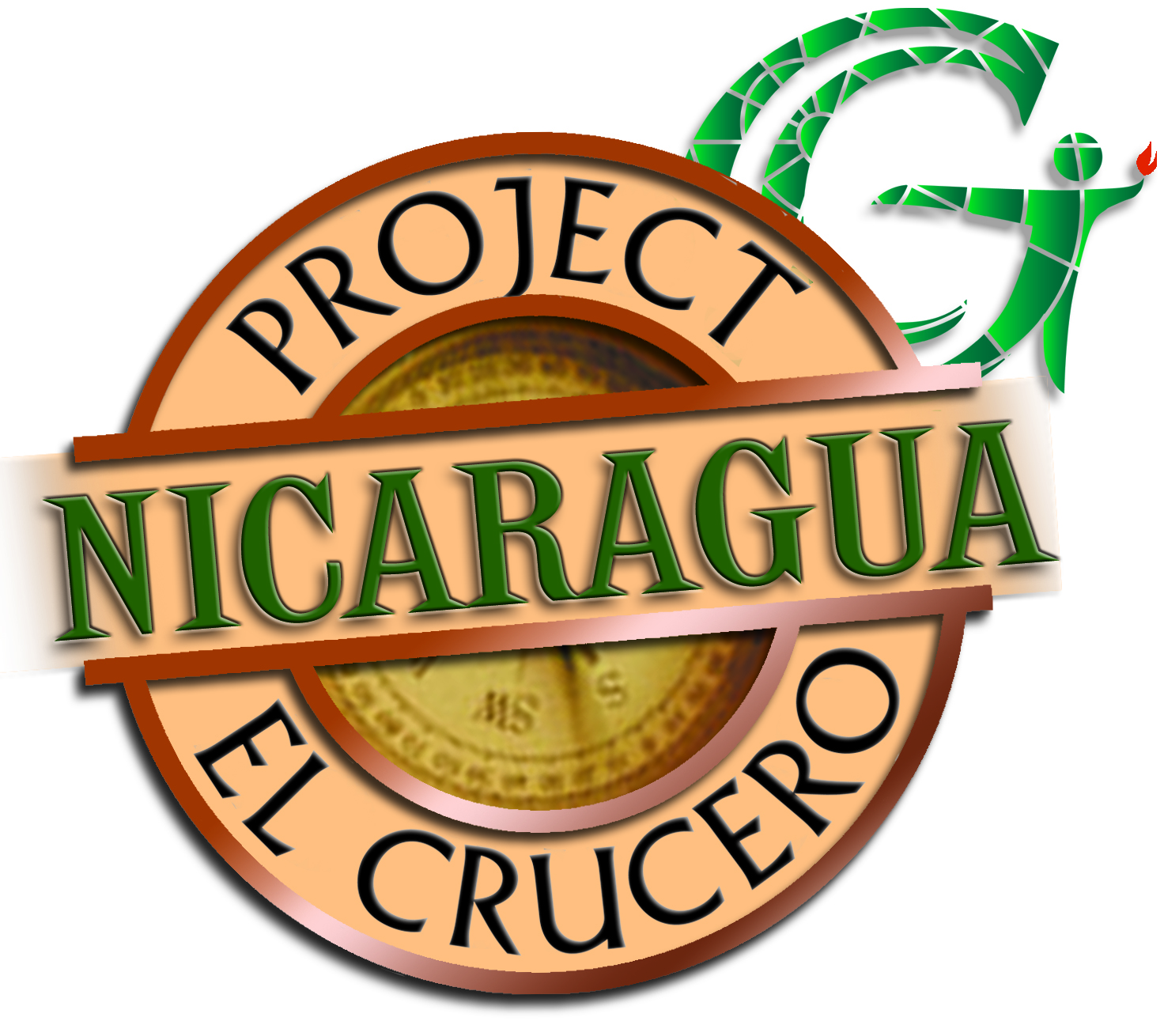

**Travel Information Packet**

**2016**

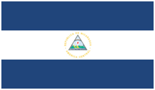

**Table of Contents**

Found within this packet is a host of information provided by Project El Crucero that is intended to assist in your trip to Nicaragua. This information will be necessary for preparing for travel and work in Nicaragua. Below is an outline of what is found within this Travel Information Packet:

Emergency Contact Information 2

General Travel Considerations 3

General Cultural Considerations 6

Participant Expectations 9

Safety Information from the Department of State 11

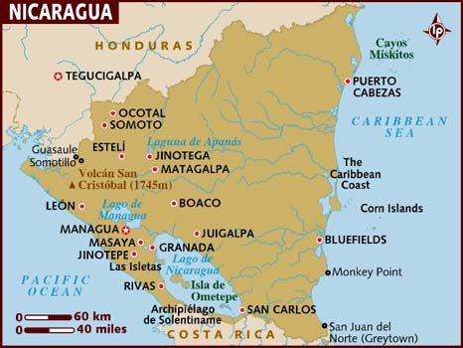

**Emergency Contact Information**

**Doug and Beth Korinek, Team Leaders**

**Cell:** 303-437-2283 (Doug); 303-946-4020 (Beth)

**Email:** bjk.korinek@yahoo.com

**Jim and Dee Nock, Apprentice Team Leaders**

**Cell:** 303-905-7033 (Jim); 303-907-1996 (Dee)

**Email:** [deenock@me.com](mailto:deenock@me.com)

**Discover the World, Cherry Hills Community Church**

**Abbie Anderson and Kevin Ross**

**Phone:** 303-791-4100

**Email:** [Abbiejohnson@CHCC.org](mailto:Abbiejohnson@CHCC.org); [KRoss@CHCC.org](mailto:KRoss@CHCC.org)

**In-Country Contact:** Dr Luiz Ocampo

**Phone:** 011 505 8151 5912

**Hotel Mozonte, ManaguA**

**Phone:** 011 505 2266-0686; [info@hotelmozonte.com](maito:info@hotelmozonte.com)

**US Embassy in Nicaragua**

Kilometer 5.5 Carretera Sur,

Managua, Nicaragua

Ambassador: Charles C. Barclay

**Telephone**: (505) 2252-7100

[www.nicaragua.usembassy.gov](http://www.nicaragua.usembassy.gov)

[acs.managua@state.gov](mailto:acs.managua@state.gov)

**Nicaraguan Embassy in the us**

1627 New Hampshire Ave, NW, Washington D.C 20009     
Telephone: (202)939-6570

[**www.Nicaraguaembassy-us.org**](http://www.Nicaraguaembassy-us.org)

Ambassador: **Robert L. Callahan**

**To Call Nicaragua from the US:** 011 (505) + (local number)

**To Call US from Nicaragua:** +001+ (number)

**General Travel Considerations**

Thank you for making this mission possible! Your team will deliver Christ’s love and hope to a community in need.

**General Expectations**

* Remember that you are a guest in a foreign country, and your American rights do not necessarily apply. Be aware of different laws and customs.
* Carefully read the country background information included in your Travel Packet, refer to your team leader with any questions.
* Be flexible; recognize that despite careful planning the situation on the ground can change quickly, adapt to changes as they occur.
* Be professional; you are representing Project El Crucero as well as the U.S., do not speak or act in a way which reflects poorly on these organizations.

**Survival Tips**

* Always carry your passport with you. Memorize your passport number in case it’s lost or stolen. Have a photocopy of both your passport in a secure place. Leave a passport copy with someone at home.
* Carry a business card for your hotel with its name and address written on it, especially in non-English speaking countries. When you are returning to the hotel, simply show this information to taxi drivers to ease the return trip.
* Carry with you the list of contact names and phone numbers.
* Be cautious of how much money you carry, when and where you remove it to mitigate the chances of theft or loss.

**Airport Expectations**

* Arrive at least 2 hours prior to your international departure time.

**Transportation**

* DTW has arranged for the team to be met by our host’s driver.
* Use common sense: only ask directions from people of marked authority, avoid unmarked taxis, travel in groups, etc.
* Know how to use local pay phones, be sure to know how to make international call

**General Health and Food Safety**

* Before you leave, call or make an appointment with your local travel medicine clinic to ensure your vaccinations are up to date, and you have all the suggested medications. If you have any questions, Project El Crucero can help you locate a travel medicine clinic in your area.
* If any vaccines are required by the country where you will be working, travel with your yellow vaccination card.
* Contaminated food and drink are a major source of illness while traveling. The best way to avoid falling ill is by paying careful attention to your choice of food and beverage**.**
* As a general rule, if the food is well cooked and hot it is okay to eat. Drink water that has been boiled or purified with iodine, or that come from a sealed bottle only. Other beverages that are generally safe to drink include hot beverages such as coffee or tea, and carbonated beverages from a sealed can or bottle.
* If you are not certain that a can or bottle is clean or dry use a straw when drinking.
* The best ways to avoid becoming ill are washing your hands with soap and water or antibacterial gel regularly, drinking plenty of non-caffeinated, non-alcoholic beverages, and getting plenty of rest.

**Clothing**

* Dressconservatively. Shorts are acceptable for extremely hot weather. Shorts will be modest and lont.
* Wear minimal make up, and little or no jewelry. Avoid flashy or expensive clothing and accessories.
* Pack light, do not travel with valuables, and carry important documents or items with you.
* Youwill spend a good deal of time walking. Be certain to bring comfortable, closed toed walking shoes. Do not go barefoot; many parasites and infections can be contracted through contact with soil.
* Be prepared for inclement weather. We will be there during the rainy season so there will be intermittent showers

**Insects**

* DEET is the most effective insect repellent against most biting insects.
* Avoid scented soaps, cologne, perfume, lotions, etc that can attract insects.
* Use special caution around dusk and dawn when many insects are most active; wear shoes, socks, long pants, and long sleeve shirts if the weather permits.

**Daily Backpack**

Bottle of drinking water

Personal snacks

Pen or pencil and notepad

Sunscreen & Lip Balm

Antibacterial hand sanitizer

Insect repellant

Tissue

Hat, umbrella, light jacket & other appropriate clothing or equipment for inclement weather.

**Accommodations**

* Accommodations are at Hotel Mozonte in Managua Nicaragua.
* Hotel Mozonte will provide towels, however you are advised to carry your own towel, washcloth and soap – including a beach towel for use at the hotel pool.

**Electrical Power**

Electrical power in Nicaragua is supplied at 120 volts same as the U.S. This means that no adapters **and** converters are necessary. Be prepared for frequent power outages and inconsistent access to electricity.

**Health and Travel Insurance**

Each participant will be responsible for arranging their own health insurance, if needed. CHCC will purchase traveler’s insurance, including emergency evacuation insurance, for each team member.

**Medicines**

* If you plan to bring prescription drugs, be sure they have a pharmacy label and pack them in your carry-on luggage.
* Participants are always advised to carry as small personal first aid kit including Imodium, a z-pack, antibiotic ointment, band-aids, aspirin, and antihistamines or decongestants.
* Be sure to bring sunscreen and bug spray.

**Internet/Cell Phone/PDA Access**

Check with your cell phone carrier to determine if your cell phone will work while in Nicaragua, and determine the rates for international calls, texting and data. Any personal cell phone charges will not be covered or reimbursed by CHCC. The hotel where the team is staying has free WIFI internet access.

**General Cultural Considerations**

It can be difficult to leave the comforts of home and immerse yourself in a foreign environment. It is normal for volunteers in developing countries to experience culture shock. Unexpected surprises and circumstances contribute to culture shock, and for this reason, preparation is essential. Volunteers can minimize their frustration by knowing what to expect before they arrive at their destination. The information provided in this packet is meant to help with just that.

**Initial Shock**

Common symptoms of culture shock are:

Frustration

Paranoia

Criticism of local people and customs

Oversensitivity and overreaction to minor difficulties

Changes in eating and sleeping habits

Loss of sense of humor

**Adjustment**

Gradually, as you orient yourself, you regain confidence. As this happens, your perspective becomes more balanced; you are less critical and more willing to integrate yourself into the culture of the country you are visiting.

**Emotional Roller-Coaster**

It can be shocking to experience poverty for the first time. Positive ways to cope with these feelings are to recognize that you are working to help the community and to discuss your feelings with your team leader and other group members. Regardless of your background, you are a foreigner and most individuals you come in contact with will assume you are wealthy. People may ask you for favors or money, because they see you as the solution to their health ailments and their poverty.Be careful not to promise any assistance you cannot provide during your stay, and never give cash to patients or their families.

**Tips for Coping**

* Travel with a spirit of humility and a desire to meet local people.
* Take care of yourself—eat well, exercise and get sufficient sleep.
* Do not take anything too seriously.
* Do not let others irritate you—you have come a long way to learn, to enjoy the experience.
* Cultivate the habit of listening and observing rather than seeing and hearing.
* Be aware of other people’s feelings and try to prevent behaving in a way that others may perceive as offensive.
* Spend time each day reflecting on your experiences.

**Time**

In the US, making others wait is usually considered disrespectful and rude. However, most other countries do not have the same attitude towards time and punctuality. While you are abroad, it is your responsibility to be ready for the day at the time appointed by the in-country host, and be aware of how your actions may be delaying or hurrying the group. Although you are expected to be punctual, you are also expected to be prepared to wait patiently for others, especially individuals from your host country. This is a function of a culture with a more relaxed attitude toward timeliness and schedules; do not be insulted.

**Language Barriers**

Many of the patients you encounter live in rural villages and will not speak or understand English. The local staff in Nicaragua will speak a small amount of conversational English, and translators will be provided as necessary. It can be frustrating to not speak directly with people, but remember that smiles and hand gestures go a long way in communicating and connecting with people.

**Social Etiquette**

Volunteers must dress appropriately to show respect to the host facility, prevent misunderstandings and avoid offending the local community. As a guest in another country it is your responsibility to respect the social and cultural expectations of that country.

**Trust**

Recognize that when you first arrive at the clinic site, you will be a stranger to the local staff and community. You must work to earn the trust and confidence of those around you, and prove your competence and trustworthiness. It is important to demonstrate your dedication and commitment to hard work and empathy towards the community.

**Re-entry Home**

Before you leave

* Gather the contact information of friends you would like to stay in touch with.
* Spend time reflecting on meaningful aspects of your trip: What did you learn?

**When you come**

* Be ready to experience boredom, isolation, disorientation and annoyance.
* Keep in touch with other team participants. Develop friendships with people that understand experiences of travelling to developing countries.
* Keep up to date with current event in your host country. Anything you do to maintain your connection with the world at large will solidify the significance of your trip.
* Remember that you can maximize your impact by inspiring and sharing your experience with others.
* **Participant Expectations**

**Please Observe the Following Expectations:**

* Participants are expected to represent CHCC in a professional demeanor throughout the on-site process.

* The team’s presence in El Crucero should bring importance and influence to the local team and facility. The opportunity to compliment the local team in El Crucero as the reason for the team’s presence may be in front of peers and officials during discussions, meetings, clinic visitations or meeting with people of the media**.**

**Covered Costs**

Covered Costs include round trip airfare, in-country transportation, accommodations, 3 meals per day clean water, and tourist fees.

* Air travel is booked at the best fares available at the time of booking.
* Each participant is permitted to take 1 checked bag and 1 carryon bag. Participants may also be required to check 1 additional bag of supplies as allowed by the airline. Costs associated with additional baggage fees to transport supplies for the mission are covered by CHCC.
* Participants are expected to keep the meal prices in the low to midrange.
* Bottled water is provided every day and included in the trip costs.
* Laundry is a personal expense.
* Trip costs begin when the team arrive in country and terminate upon departing from Nicaragua. Transportation to and from originating airport is a personal expense

**Team Participants Must Always:**

* Display an attitude of availability and respect.
* Be flexible. A flexible attitude is the ‘name of the game’ and may involve graciously accepting itinerary changes, accommodation difficulties, surprise interviews, public speaking engagements, long hours, early mornings, late nights, bumpy rides, and many other unexpected events.
* Be professional in appearance, in conduct, in attitude and in the delivery of information. The image of the team will set a tone for others participating with the clinic efforts.
* Follow a professional dress code. T-shirts with inappropriate messages and graphics are never appropriate for a Team Participant.
* Maintain modest hairstyles, nails, makeup, and facial hair, to avoid attracting inappropriate attention or offending individuals in the host country.
* Set an example of appropriate conduct. Intimate personal relationship with any persons directly involved with the clinic participants or host country individuals is unacceptable and will not be tolerated.

**Team Expectations**

* Work together to ensure daily clinic activities run smoothly.
* Clarify any questions about procedures at the host facility with local staff.
* Always communicate concerns or questions to the team leader.
* At no time will a participant leave the group without the knowledge of the team leader.
* Provide support and encouragement to one another and staff at the host facility.
* Never promise or pledge specific treatment or obligate Project El Crucero in any way.
* Never speak negatively of the host country.
* Avoid commenting on local, national or international political issues.

**Additional Notes**

* While in-country, working with severely underserved populations, it is possible to become focused an individual situation. Always remember that there are hundreds of locations that can benefit from the assistance from Project El Crucero. Participants cannot involve themselves in activities other than the provision of predetermined assistance during Mission.
* The Team will conduct daily briefing sessions. These sessions will set team goals and expectations, review assignments, address concerns, and offer the opportunity to share experiences and reactions. Each participant is expected to attend the daily session.

**Safety**

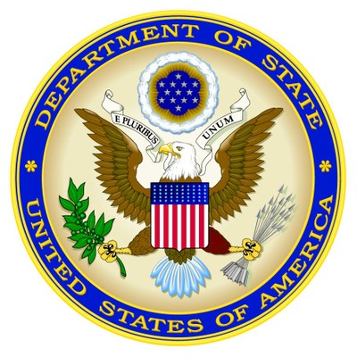**From the U.S. Department of State**

For the latest security information, Americans traveling abroad should regularly monitor the Department of State, Bureau of Consular Affairs’ website at <http://travel.state.gov>, where the current travel warnings and travel alerts, as well as the worldwide caution, can be found.

Up to date information on safety and security can also be obtained by calling 1-888-407-4747 toll free in the U.S. and Canada, or for callers outside the U.S. and Canada, a regular toll-line at 1-202-501-4444.

The Department of State urges American citizens to take responsibility for their own security while traveling overseas. For general information about appropriate measures travelers can take to protect themselves in an overseas environment, see the Department of State’s pamphlet “A Safe Trip Abroad,” on the website.

The loss of theft abroad of a U.S. passport should be reported immediately to the local police and the nearest U.S. Embassy or Consulate. If you are the victim of a crime while overseas, in addition to reporting to local police, please contact the nearest U.S. Embassy or Consulate for assistance. The Embassy/Consulate staff can, for example, assist you to find appropriate medical care, contact family members or friends and explain how funds could be transferred.

U.S. citizens should carry a copy of their U.S. passport with them at all times. Credit cards may be used at some major hotels, but are not widely accepted in Nicaragaua.  In the larger urban areas, ATM machines are usually available at major banks.  However, travelers should exercise caution when using ATM, debit, and credit cards in Nicaragua.  There have been numerous recent reports from U.S. citizens of fraud, particularly against U.S. dollar denominated accounts.

Travelers should bring sufficient cash or traveler’s checks for their trip if they will be spending time outside of the large cities.  Individuals should be advised that reputable financial institutions require that the holder of Travelers Checks present the original receipt for the checks and proof of identity before the institutions will complete a transaction.